**ABSTRACT**

The main objective of this project is to investigate the degree of association between citizen complaint and their complaints about the issues in particular area for that we creating a web application in an implementation of E-complaint analysis for quick response to citizen complaints. Citizen Complaints are considered vital and significant information that can be utilized to attain citizen’ satisfaction. The Citizen Complaint Analysis System that can be effective in reducing citizen’ complaints through participating citizen. The system starts by discussing the service implementation with the web-application interface development. These services have been explored to obtain the Citizen and Officer data and find out about how they are Working.we have been implemented in this application, each according to the operation that calls the service to restore certain data, Most important reports extracted from the evaluation results.For implementing the module, a web application has been developed to exhibit both the ability of the module and the efficiency in e-Gov, since that web application could be developed thoroughly.

**AIM OF THE PROJECT**

This project aims to develop a robust and responsive system for handling complaints submitted by citizens, ensuring that they are resolved promptly and effectively. By analyzing existing challenges and proposing a dynamic, automated solution, this project enhances the speed, efficiency, and accountability of the complaint resolution process.

**INTRODUCTION**

Efficient complaint management systems play a critical role in maintaining the trust and satisfaction of citizens in any governance model. In today's fast-paced world, citizens expect quick responses and resolutions to their grievances..However, traditional systems often fall short of meeting these expectations due to delays, inefficiencies, and lack of accountability. These shortcomings frustrate citizens and lead to mistrust in the administration. The need for an efficient system that allows authorities to respond promptly, transparently, and effectively is greater than ever.

**"Analysis for Quick Response to Citizen Complaints"** is designed to tackle these challenges by implementing a digital, automated complaint management system. It focuses on reducing delays, streamlining complaint handling, and enhancing the overall efficiency of public grievance redressal. And this project emphasize the Real-time complaint tracking Citizens can monitor the status of their complaints . Efficient task allocation Automated systems assign complaints to the right personnel based on their nature, location, and urgency.Accountability and feedback Ensures strict monitoring of officers' performance and encourages citizens to provide feedback for continuous improvement.This system not only fosters transparency and trust but also aligns with the broader goals of modern governance by leveraging technology for the betterment of public services.

**PROBLEM STATEMENT**

Efficient complaint management is critical for maintaining the trust of citizens in public administration. Unfortunately.Challenges in theCurrent System is Manual Processes and Delays that is Most complaint management systems still rely on manual processes such as paper-based submissions, emails, or phone calls.These methods are time-consuming, prone to human errors, and lead to delays in recording, tracking, and resolving complaints and Citizens are often required to visit administrative offices multiple times to follow up on their complaints, wasting time and resources.Lack of Structured Assignment that is Efficient complaint management is critical for maintaining the trust of citizens in public administration. Unfortunately, traditional systems are fraught with inefficiencies that lead to delays, poor resource allocation, and a lack of transparency. This negatively impacts citizens' experience and satisfaction, reducing the effectiveness of governance.

No Real-Time Tracking and Updates for Citizens Citizens have limited visibility into the status of their complaints after submission.the absence of real-time updates leaves them in the dark about whether their complaints are being addressed or ignored.This lack of communication causes frustration and dissatisfaction.Limited Accountability and Monitoring and .Repetition and Redundancy Multiple citizens reporting the same issue often results in duplicate complaints, overwhelming the system and delaying resolution for other unique problems.This duplication creates unnecessary workloads for officers, who must manually consolidate and address repetitive complaints also Resource Inefficiency

**OBJECTIVE OF THIS PROJECT**

The primary objective of the Analysis for Quick Response to Citizen Complaints project is to design and implement an efficient, automated, and dynamic system for managing citizen complaints. This system aims to address inefficiencies in the traditional grievance redressal process, improve response times, enhance accountability, and provide transparency to citizens.

**SPECIFIC OBJECTIVES**

1. **Enhance Efficiency**: Automate the complaint handling process to reduce delays and manual errors.
2. **Streamline Task Assignment**: Categorize complaints and assign them to the appropriate personnel based on location, urgency, and nature.
3. **Provide Transparency**: Enable citizens to track the status of their complaints in real time, reducing frustration and uncertainty.
4. **Ensure Accountability**: Monitor the performance of employees handling complaints and introduce measures for strict action against negligence or delays.
5. **Improve Resource Utilization**: Avoid duplication of effort by consolidating similar complaints and prioritizing unique issues.
6. **Foster Citizen Trust**: Build public confidence in governance through a responsive, transparent, and citizen-centric system.

**EXISTING SYSTEM**

The existing system for handling citizen complaints typically involves traditional, manual processes where complaints are submitted through physical visits, phone calls, or written formats. In some modernized systems, complaints are submitted through digital platforms such as websites, mobile apps, or social media channels. Once a complaint is received, it is either logged manually or automatically categorized and forwarded to the relevant department for resolution. Citizens may receive an acknowledgment or response, but updates are often delayed and limited. Follow-ups may involve additional manual interactions between citizens and government personnel, contributing to prolonged resolution times.

However, this system presents several significant disadvantages. One of the primary drawbacks is inefficiency, as the manual handling of complaints and responses can be time-consuming, leading to delayed responses. This inefficiency is exacerbated in systems that lack automated workflows or real-time updates. Another major issue is the lack of transparency ,citizens may not be informed about the status of their complaints, and tracking progress can be cumbersome for both the citizens and authorities. Additionally, traditional systems tend to rely on limited communication channels, excluding those without internet access or digital literacy, which reduces the accessibility of the complaint process for certain demographics.

**DISADVANTAGES**

* 1. **Manual Handling**: Traditional, paper-based systems or manual entry in digital systems lead to inefficiencies and slow response times
  2. **Response Delays**: Due to bottlenecks in processing and communication, citizens may experience long delays in the response or resolution of their complaints.
  3. **Accessibility Issues**: Citizens without access to the internet, smartphones, or digital platforms may be excluded from the complaint system, leaving certain demographics underrepresented.
  4. **Geographic barriers**: Complaints in remote or rural areas may face challenges in reaching authorities due to limited infrastructure or low awareness about complaint systems.
  5. **Single-channel reliance**: Some systems rely on only one or two communication channels (e.g., phone, email), which might not be the most effective for all citizens.
  6. **No direct feedback loop**: If there is no mechanism to gauge citizen satisfaction after resolution, authorities may be unaware of the effectiveness of their responses.
  7. **Overwhelmed systems**: During high volumes of complaints, the system may treat all complaints with equal priority, risking delays in high-priority issues.
  8. **Poor data storage**: Complaints may not be properly documented, or the data may be stored in silos across departments, leading to difficulty in analyzing trends, performance, and areas requiring improvement.
  9. **Lack of analytics**: Traditional systems may not be able to analyze the complaints data effectively, meaning departments cannot easily identify recurring issues or prioritize resources for the most impactful problems.
  10. **Inadequate tracking**: Some systems fail to clearly identify who is responsible for the resolution of a complaint or how long it will take, leading to lack of accountability. Also Loss of complaint records: complaints may get lost or mishandled, leading to unresolved issues and dissatisfied citizens.

**PROPOSED SYSTEM**

The proposed system for handling citizen complaints would modernize and optimize the entire process, moving away from traditional methods and embracing an integrated digital approach. The system would be designed to ensure quick responses, efficiency, transparency, and accessibility for all citizens, regardless of their geographic location or technological proficiency. It would combine mobile applications, web portals, and automated processes to enable citizens to submit complaints instantly, track their progress, and receive prompt resolutions.

**Advantages of the Proposed System:**

1. **Efficiency and Speed**:
   * The automated features of the system would significantly speed up the complaint resolution process. With automated routing, categorization, and prioritization, complaints would be directed to the right department or personnel without delay, reducing wait times.
2. **Enhanced Transparency**:
   * Real-time tracking and regular updates would provide citizens with full visibility into the status of their complaints, fostering a sense of trust and transparency in the system. Citizens would no longer be left in the dark about the progress of their complaints, which would build confidence in government responsiveness.
3. **Responsiveness**:
   * The ability to monitor the resolution time and effectiveness of responses would also allow authorities to optimize their processes and improve service delivery.
4. **Improved Citizen Satisfaction**:
   * By providing real-time updates, prompt resolutions, and transparent communication, the system would increase citizen satisfaction. The feedback mechanism would ensure that the system continuously improves based on user input, leading to better service delivery.
5. **Better Resource Allocation**:
   * With the data analytics capabilities of the system, government departments would be able to analyze complaint trends and allocate resources more effectively. This would allow for more targeted interventions and proactive measures to address recurring problems before they escalate.
   * The insights gained from complaints data could also inform long-term planning, ensuring that resources are directed to areas with the most significant needs.
6. **Increased Accessibility** 
   * The system’s support for multiple channels, languages, and accessibility features would ensure that all citizens, including those with disabilities or limited technological access, can submit complaints and benefit from quick responses.
7. **Continuous Improvement and Innovation**:
   * By leveraging feedback, data analytics, and citizen input, the system would evolve and adapt to meet the changing needs of the public. This focus on continuous improvement would allow the government to respond to emerging issues more effectively and to innovate in its approach to service delivery.

# MODULES

* Admin module
* User module

# MODULE DESCRIPTION

The **E-Complaint Management System** consists of two key modules: **Admin Module** and **User Module.** Each module plays a crucial role in ensuring smooth complaint registration, tracking, and resolution. Below is a detailed description of both modules:

### **1. Admin Module**

The **Admin module** is responsible for managing the entire complaint system, ensuring complaints are handled efficiently, categorized properly, and resolved in a timely manner. The key functionalities of the Admin module include:

* **Admin Login:** The Admin must log in using a secure username and password to access the dashboard.
* **Manage Categories & Subcategories:** Admins can add, edit, and delete complaint categories and subcategories to classify complaints appropriately.
* **Manage States:** Admins can add different states to categorize complaints based on geographical locations.
* **View and Manage Complaints:**
  + Admins can view all complaints registered by users, along with details such as complaint category, date of submission, and complaint description.
  + Complaints are displayed with their current status (e.g., Pending, In Progress, Resolved).
  + Admins can update the status of complaints based on the progress of their resolution.
* **Change Password:** The Admin can update their password to ensure security and prevent unauthorized access.
* **Logout:** Securely log out from the system to prevent unauthorized access.

### **2. User Module**

The **User module** allows individuals to register complaints, track their progress, and manage their account details. The key functionalities of the User module include:

* **User Registration & Login:** Users must register by providing their details (name, email, contact number, etc.) and create a password to log into the system.
* **File a Complaint:**
  + Users can register a complaint by selecting a category and subcategory relevant to their issue.
  + They can provide a detailed description of their complaint along with any supporting documents or attachments (if applicable).
  + Once submitted, the complaint is stored in the system and assigned a unique complaint ID for tracking.
* **Track Complaint Status:** Users can log in to check the current status of their complaint, which is updated by the Admin as it progresses.
* **Change Password:** Users can update their login credentials for security purposes.
* **Logout:** Users can securely exit the system to protect their account.

# SYSTEM SPECIFICATION

* 1. **HARDWARE REQUIREMENTS:**

SYSTEM : Intel i3 2.6 GHz

HARD DISK : 500 GB

MONITOR : 15 VGA MOUSE : Logitech.

RAM : 2 GB Ram

KEYBOARD : 110 keys enhanced.

# SOFTWARE REQUIREMENTS:

Operating system : Windows Family

Front End : HTML, CSS, Javascript

Back End : **PHP**

Database : **MySQL**

**USER CASE DIAGRAM:**

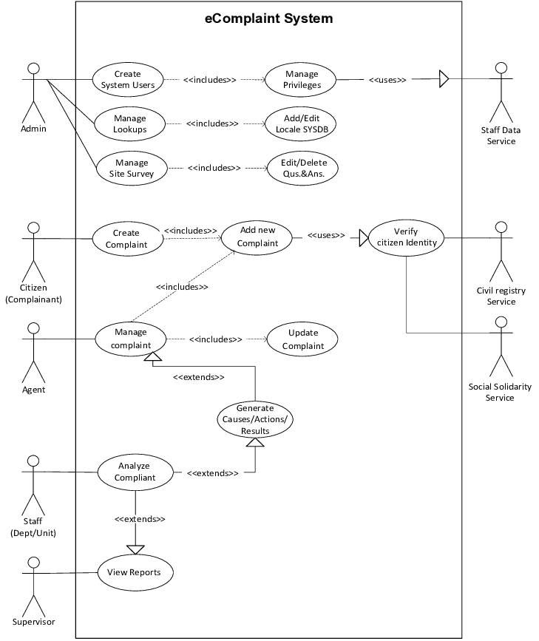

**SEQUENCE DIAGRAM**

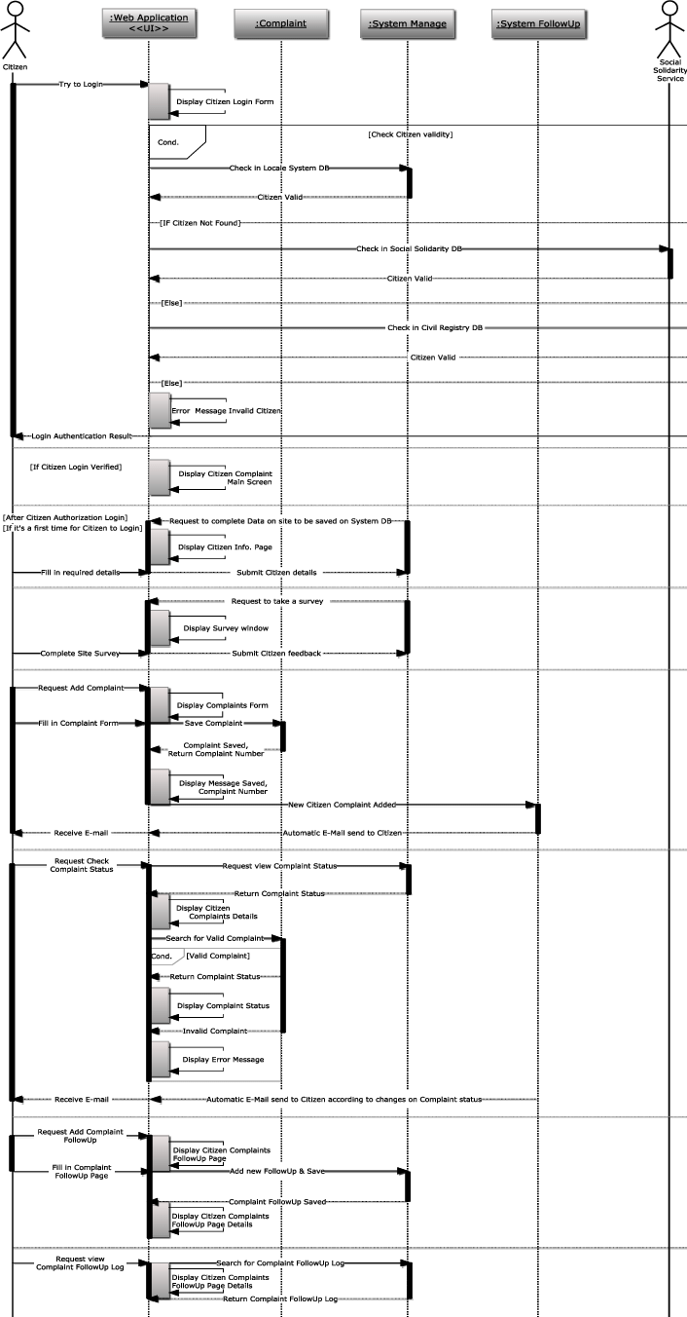

**PROPOSED WORK FLOW DIAGRAM**

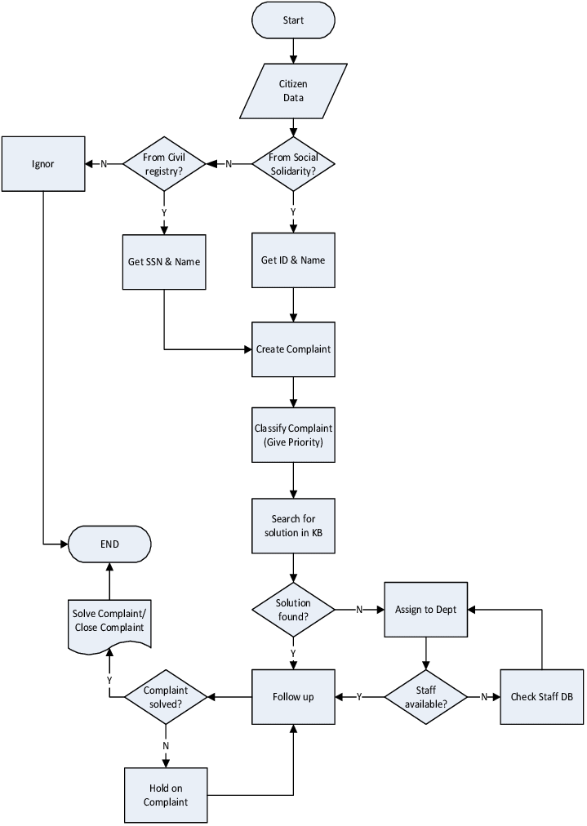

**OUTPUT DESIGN**

**Home page**

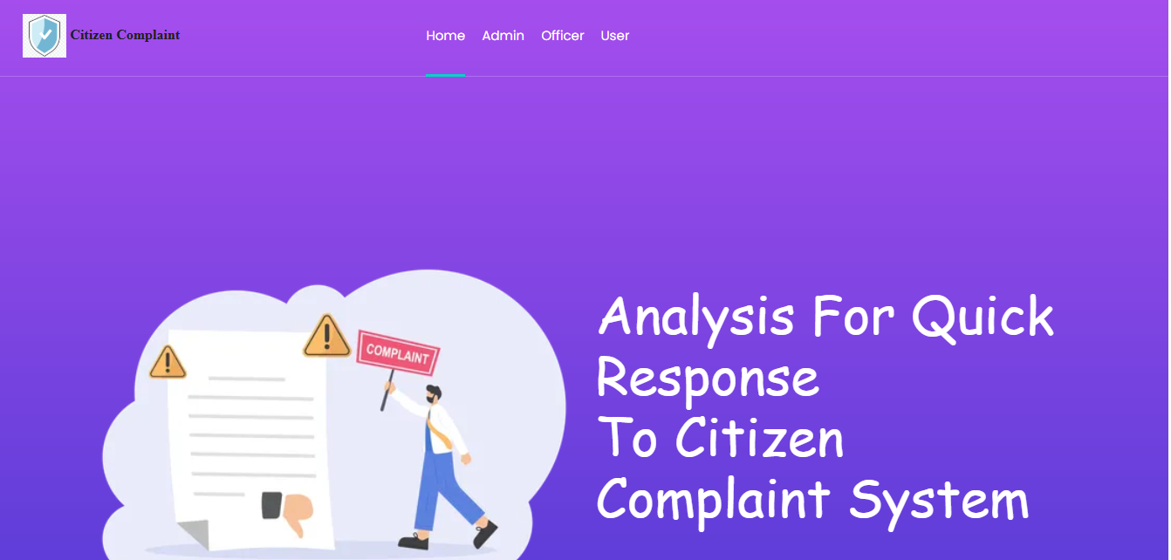

**USER REGISTRATION**

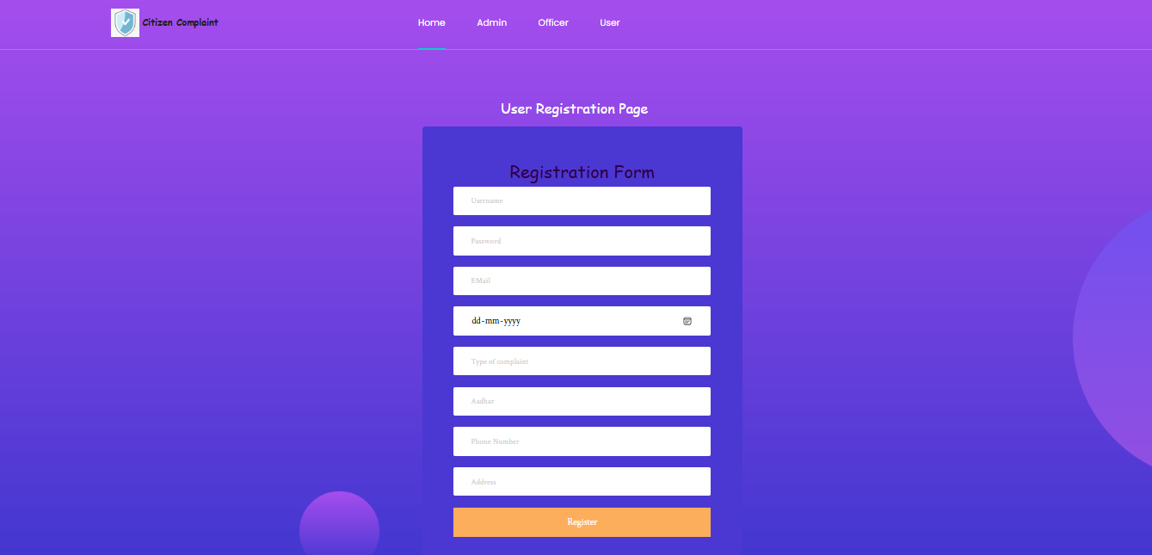

**USER LOGIN**

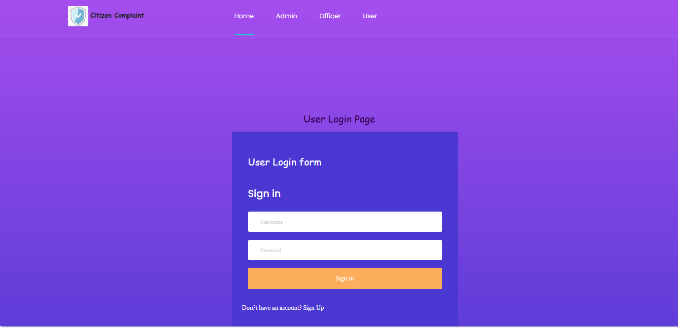

**ADMIN HOME PAGE**

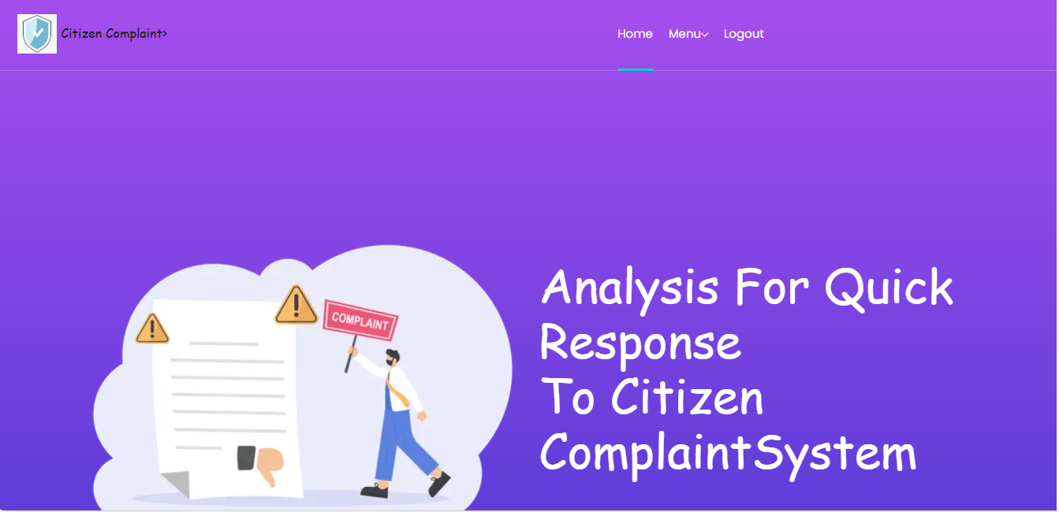

**Admin login**

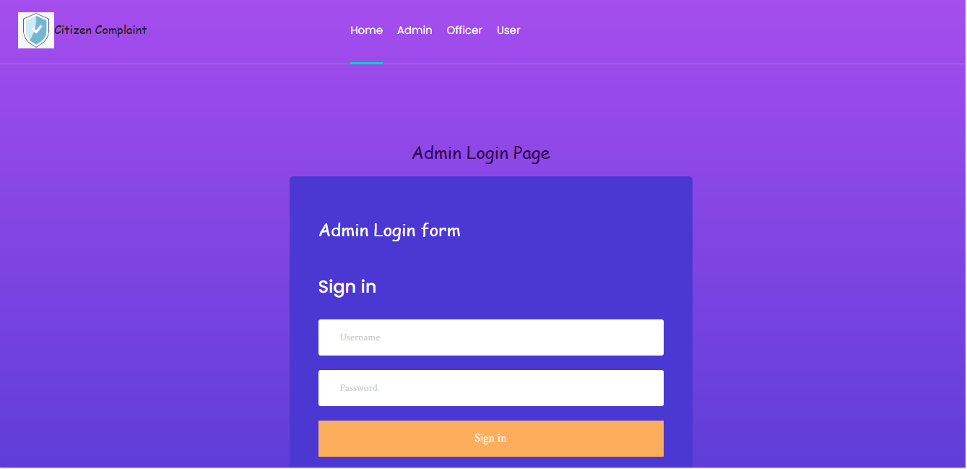

**TABLE DESIGN**

In Analysis for quick response to citizen complaint project 3 tables are created for the proposed project. They are;

* Admin login
* User Registration
* Officer login

**1. Admin Login Table**

The Admin Login Table stores information about the administrators of the system. These individuals manage and oversee the operations of the application, such as viewing all of user and update complaint status , and handling critical system configurations.

**Table name** : admin

|  |  |  |  |  |  |
| --- | --- | --- | --- | --- | --- |
| **S.no** | **FIELD NAME** | **DATA TYPE** | **SIZE** | **CONSTRAINT** | **DESCRIPTION** |
| 1. | admin_name | varchar | 100 | DEFAULT NULL | admin_name |
| 2. | password | varchar | 100 | DEFAULT NULL | password |

**2.User registration :**

The User registration table stores details about individuals data. And give status of type complaint.

**Table name** : User_reg

**Primary_key** : User_id

|  |  |  |  |  |  |
| --- | --- | --- | --- | --- | --- |
| **S.NO** | **FIELD NAME** | **DATA TYPE** | **SIZE** | **CONSTRAINT** | **DESCRIPTION** |
| 1. | User_id | int | 50 | NOT NULL | User_id |
| 2. | name | varchar | 100 | DEFAULT NULL | name |
| 3. | password | varchar | 100 | DEFAULT NULL | password |
| 4. | email | varchar | 10 | UNIQUE | email |
| 5. | dob | date | - | DEFAULT NULL | dob |
| 6. | Type of complaint | varchar | 200 | DEFAULT NULL | Type of complaint |
| 7. | aadhar | int | 12 | DEFAULT NULL | aadhar |
| 8. | Phone number | int | 10 | DEFAULT NULL | Phone number |
| 9. | Address | varchar | 100 | DEFAULT NULL | Address |

**3. Officer Login Table**

The Officer Login Table stores details about individual data. These individuals manage and oversee the operations of the application, such as viewing all of user and update complaint status .

**Table name** : officer

|  |  |  |  |  |  |
| --- | --- | --- | --- | --- | --- |
| **S.no** | **FIELD NAME** | **DATA TYPE** | **SIZE** | **CONSTRAINT** | **DESCRIPTION** |
| 1. | Officer_name | varchar | 100 | DEFAULT NULL | Officer_name |
| 2. | password | varchar | 100 | DEFAULT NULL | password |

**REFERENCES**

1. İli, N. D., Deniz, G., Çokal, Z., & Yılmaz, N. (2024). Evaluation of E-Complaints About Balloon Tours in Cappadocia, Turkey. Yaşar Üniversitesi E-Dergisi, 19(74), 267

2. Lee, C. C., & Hu, C. (2005). Analyzing Hotel customers' E-complaints from an internet complaint forum. Journal of Travel & Tourism Marketing, 17(2-3), 167-181.

3. Şengül, S., Çavuş, O., & TAŞKIN, E. (2018). Analysis of e-complaints for restaurant enterprises in the World's 50 best restaurant list. Journal of Tourism & Gastronomy Studies, 6(1), 320-334.

4. Aydın, Ü. N. A. L., ÇELEN, O., & BAYAR, S. B. (2021). A STUDY ON THE ANALYSIS OF E-COMPLAINTS AGAINST FOOD AND BEVERAGE BUSINESSES: THE CASE OF ALAÇATI. SSD Journal, 6(28), 105-122.

5. Çavdırlı, C. M., & Gök, Ö. A. (2022). AN EVALUATION OF E-COMPLAINTS OF CHILDFRIENDLY HOTELS. Beykoz Akademi Dergisi, 2(1), 55-68.

6. Atalan, A. (2023). The ChatGPT application on quality management: A Comprehensive Review. Available at SSRN 4565125.

7. Ojo, A. K., & Adeyemo, A. B. (2013). Knowledge discovery in academic electronic resources using text mining. International Journal of Computer Science and Information Security, 11(2), 10-19.

8. Achetib, N., Leemberg, C. C., Geurts, M. M., Bloemen, P. R., van den Elzen, R. M., Aalders, M. C., & van Dam, A. (2023). Towards Onsite Age Estimation of Semen Stains Using Fluorescence Spectroscopy. Sensors, 23(13), 6148.

9. Achetib, N., Leemberg, C. C., Geurts, M. M., Bloemen, P. R., van den Elzen, R. M., Aalders, M. C., & van Dam, A. (2023). Towards Onsite Age Estimation of Semen Stains Using Fluorescence Spectroscopy. Sensors, 23(13), 6148.

10. Koruyan, K. U. T. A. N. (2022). BERTopic Konu Modelleme Tekniği Kullanılarak Müşteri Şikayetlerinin Sınıflandırılması. İzmir Sosyal Bilimler Dergisi, 4(2), 66-79.

11. Smith, J., & Johnson, A. (2019). Understanding Customer Complaints in the Hospitality Industry: A Case Study of Luxury Hotels. Journal of Hospitality Management,

12(3), 45-58. 12. Wang, L., & Zhang, H. (2020). Analyzing E-Complaints in the Airline Industry: A Customer Perspective. International Journal of Aviation Management, 8(1), 102-115.